
Computer Programming
PROJECT BASED LEARNING- Object oriented programming

Submitted to:
Sir Furqan Hameed Khan

Submitted by:
Muhammad Hamzah Iqbal (F24604018)
Maryam Khan Jadoon (F24604066)

Department of Computer Engineering
National University of Technology

Question:
Students Management System Develop a console-based management system application to manage student records for an educational institution. The system should enable administrators to add, modify, delete, and search for student information? It should also allow to sort records based on different criteria.
Mandatory Features: The system must implement a student class that inherits from some other base class. Your program should store student records in a file (for example a csv file) and read/write data from/into that file. You can also search/sort student records by their name, registration id, etc.

Project Overview
Managing student data efficiently is vital for any educational institution. This console-based application leverages Object-Oriented Programming (OOP) principles to develop a Student Management System that allows administrators to manage student records interactively. It supports various operations such as adding, updating, deleting, sorting, and visualizing student data.

Objectives
- Create a robust and reusable class structure using OOP.
- Implement persistent storage using CSV files.
- Provide user-friendly features like record sorting and visual analytics.

System Design and Implementation
The system is structured into three main classes:
1. PersonData (Base Class):
- Stores basic personal information such as name and age.
2. AcademicRecord (Derived Class):
- Inherits from PersonData and adds student ID, academic program, and gender.
3. RecordSystem:
- Handles the logic for file operations, data manipulation, searching, sorting, and visualization using matplotlib.
Key Features
- Add New Record: Interactive input from users with ID verification.
- Display Records: Neatly formatted table view.
- Update Record: Edit existing entries with optional field skipping.
- Delete Record: Remove students by ID.
- Sort Records: Sort by name, ID, or program.
- Search Record: Locate a student by ID.
- Visual Analytics: Gender distribution pie chart.

Project Work Allocation
We began the project by understanding the problem: to create a console-based Student Management System using Object-Oriented Programming (OOP). After reading the requirements, we discussed how to break the project into parts that we could work on individually.
First, we designed the basic structure of the program. We created a base class called PersonData that stores simple information like the student's name and age. Then we made another class called AcademicRecord that builds on the base class and includes more details like student ID, program, and gender.
Once the classes were ready, we created a RecordSystem class that handles all the tasks like adding, updating, searching, deleting, and saving student data.
We divided the work as follows:
- Maryam created the main menu and developed the functions for adding, deleting, and viewing records. She focused on making the system simple and user-friendly.
- Muhammad Hamzah Iqbal worked on the functions for updating records, searching, sorting, saving/loading data, and generating the gender distribution pie chart. He also developed the class structure and logic behind the data handling.

To make data handling more efficient, we used the panda’s library, which allowed us to easily manipulate and analyze the student data, improving overall performance and flexibility. Pandas also helped simplify the implementation of sorting and filtering features. Additionally, we created a detailed flowchart to visualize the system’s workflow, which helped us understand the user interactions better and streamline the program logic. The flowchart improved user experience by providing data analysis and making the system more accessible. Each feature was tested after development to ensure that it worked correctly.
Code:
Below is the proposed solution for the question.
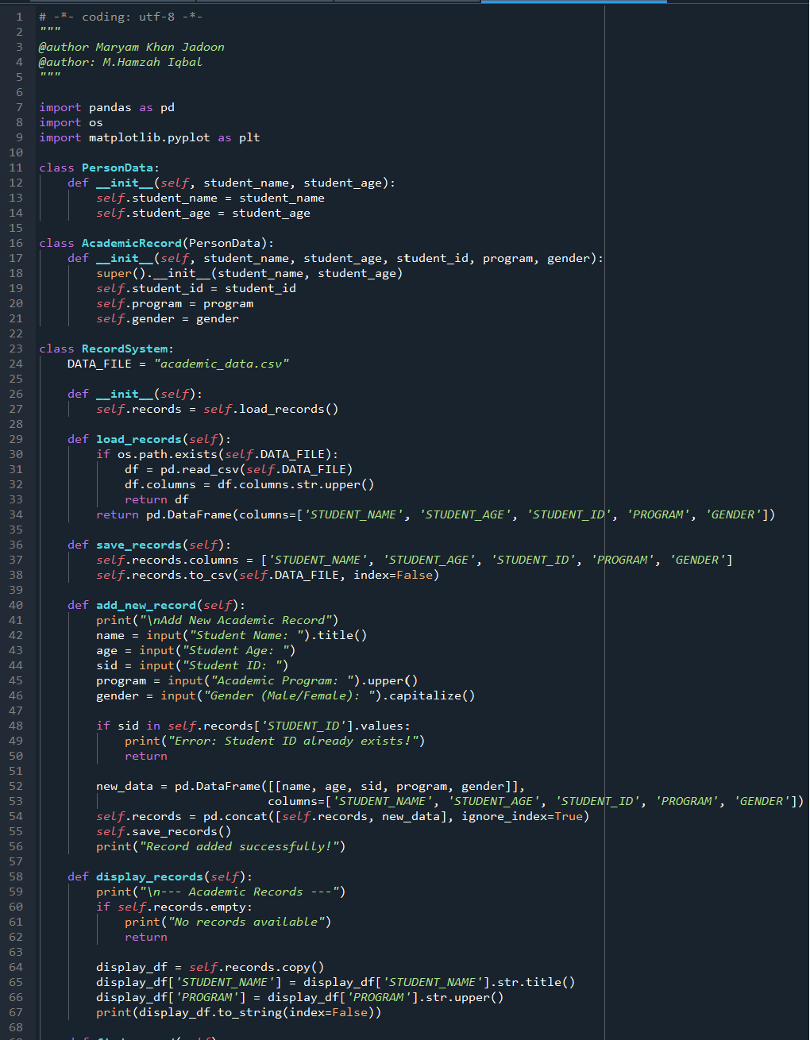

Figure 1: Code lines 1-68
Figure 3: Code lines 79-118

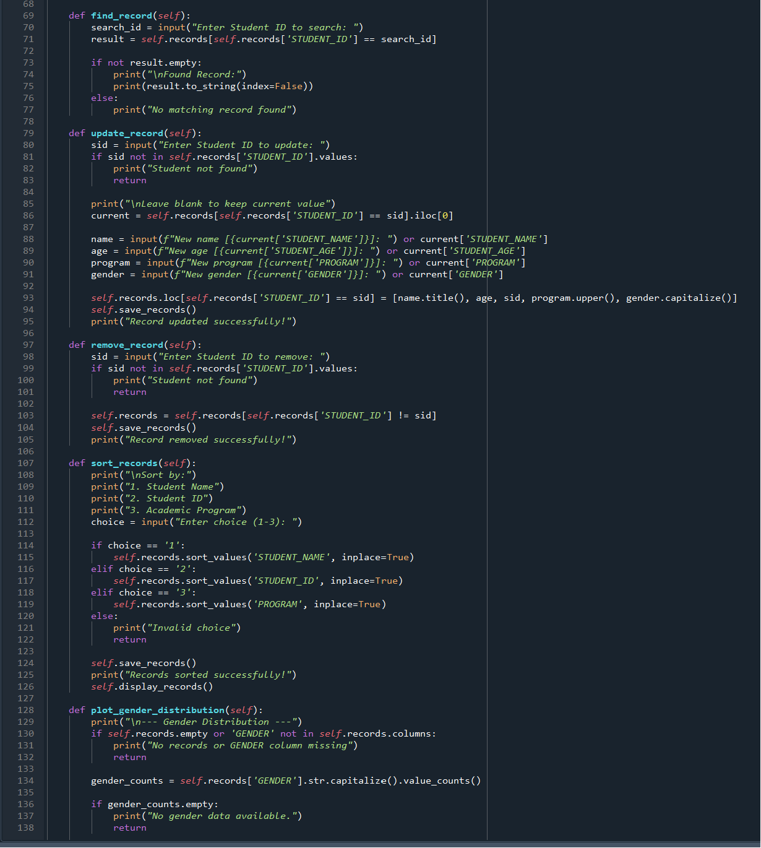


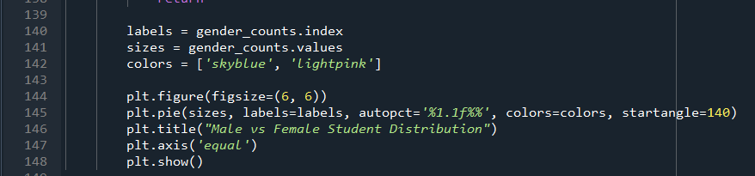
Figure 2: Code lines 68-148
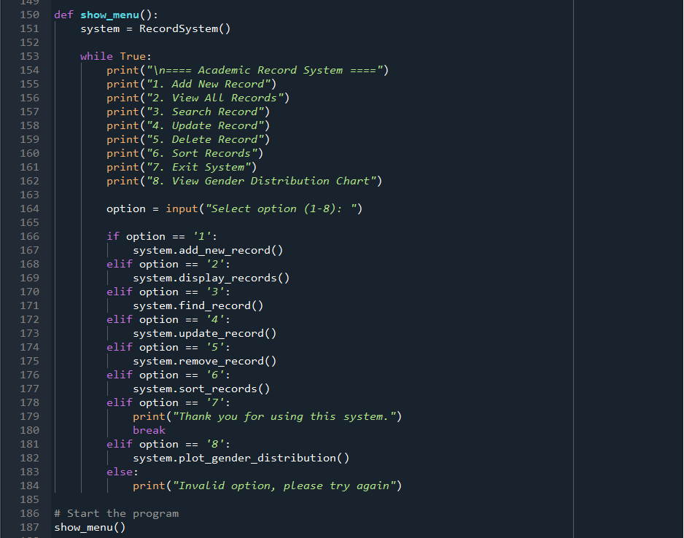

Figure 3: Code lines 149-188

Explanation:
Imports:
We have imported three libraries:
- Import pandas: For handling and analyzing tabular data (like Excel tables).
- Import os: For checking if a file exists on your computer.
- Import matplotlib.pyplot: To plot charts (like pie charts) for visual data.

Classes and functions:
PersonData class | This is a base class. It stores basic information: name and age of a student.
AcademicRecord class | This class inherits from PersonData, and adds:  - student_id  - program  - gender  It holds complete info about a student.
RecordSystem class | Constants & Constructor:  DATA_FILE = "academic_data.csv"  This sets the CSV file name where records will be stored.  def __init__(self):  self.records = self.load_records()  When you create a RecordSystem object, it loads data from the CSV (if available), or creates an empty table.
load_records() | This function:  - Checks if the data file exists.  - If it does, loads it into a DataFrame.  - If not, it creates a blank DataFrame with proper columns.
save_records() | This function saves the current records into the CSV file.
add_new_record() | This lets the user add a new student. It:  - Takes input from the user.  - Checks if the student ID already exists.  - If not, adds the new student to the table and saves it.
display_records() | Displays all students in a neat format (like a table). If no data exists, it says so.
find_record() | Searches for a student by their ID and shows the result if found.
update_record() | Allows updating a student’s info. The user can leave a field blank to keep the current value.
remove_record() | Removes a student’s record based on their ID.
sort_records() | Sorts the records based on:  - Student name  - Student ID  - Academic program  It also shows the sorted list.
plot_gender_distribution() | Creates a pie chart of how many students are Male vs Female.
show_menu() | This is the main menu that runs in a loop. It:  - Creates a RecordSystem object.  - Shows options to the user like Add, View, Search, Update, Delete, Sort, Plot, and Exit.  - Calls the right function based on user input.

OUTPUT:
Below is the output for the above code.
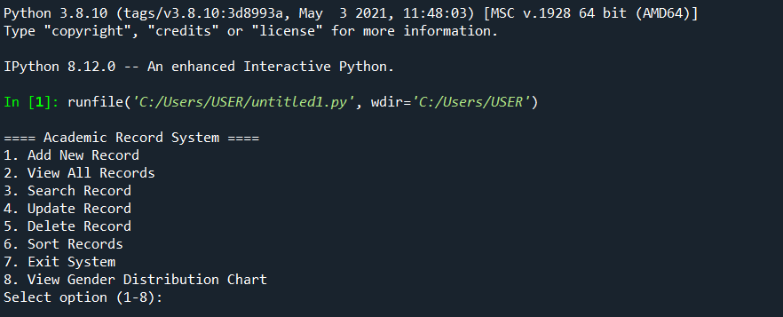

Add record:
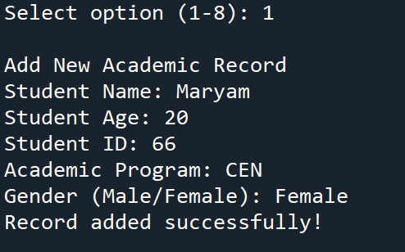

View Record:

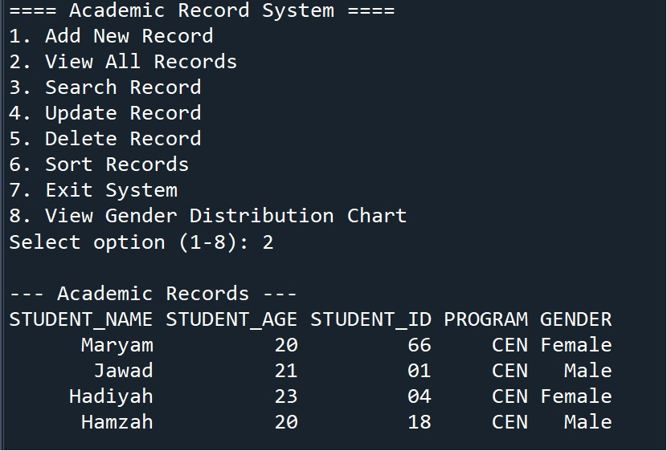

Search record:
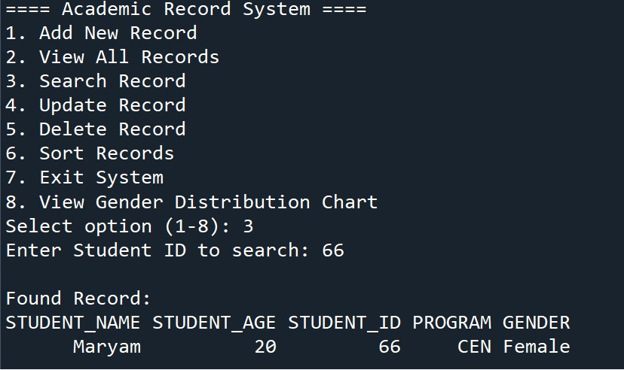

Update record:
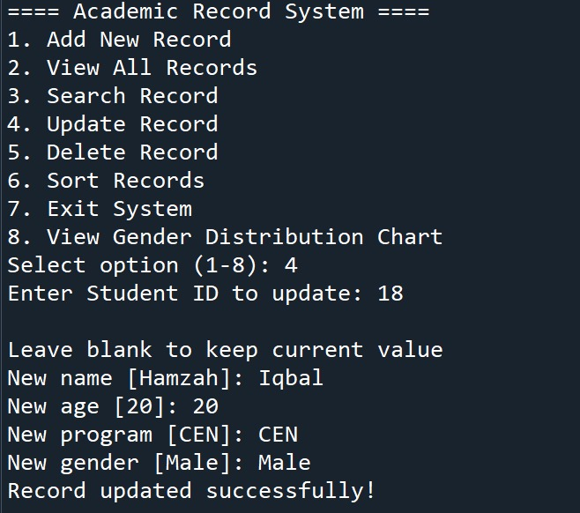

Delete record:
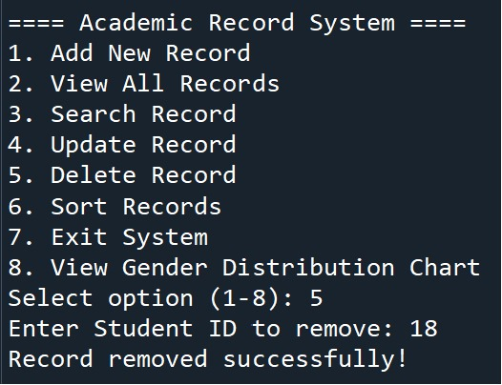

Sort Record
- Sort by name:
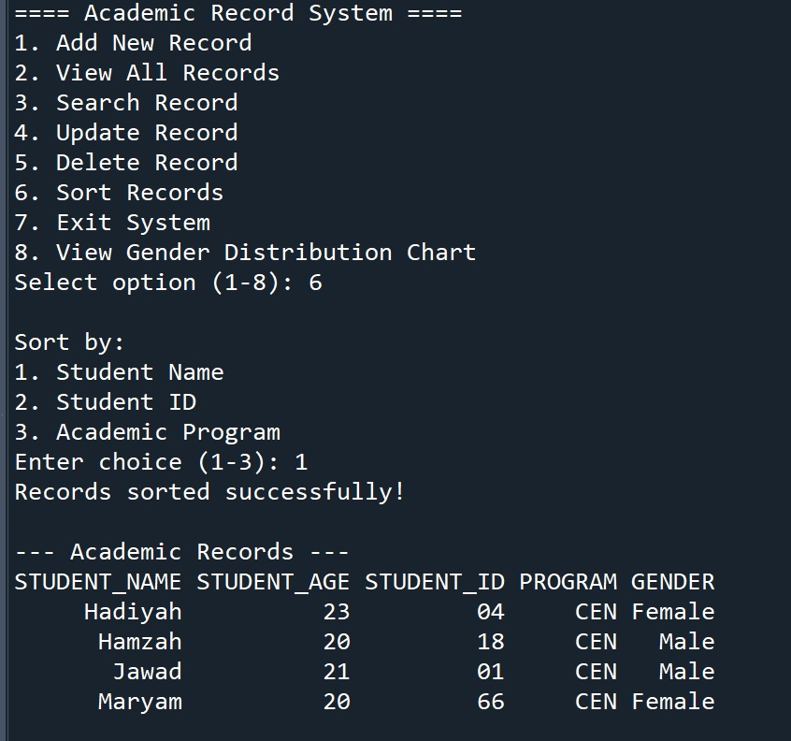

- Sort by ID
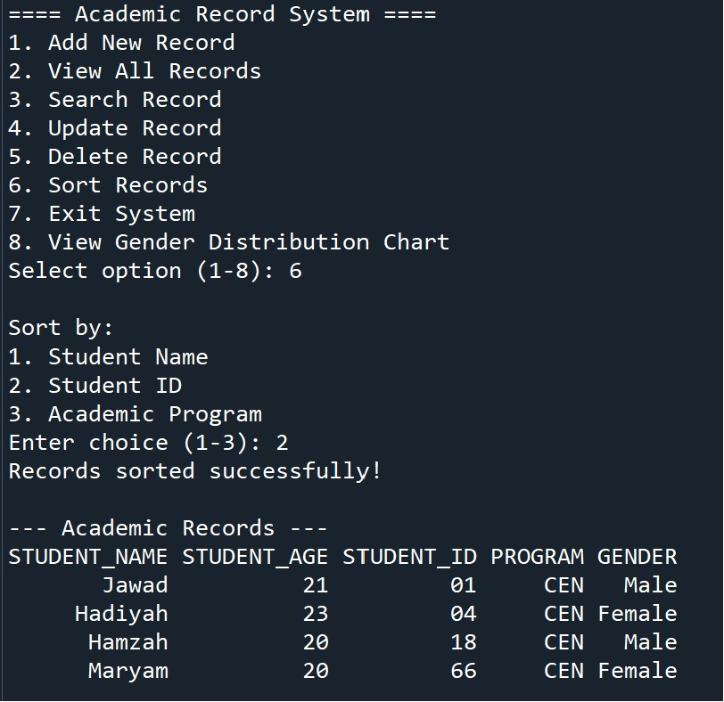

- Sort by Academic Program
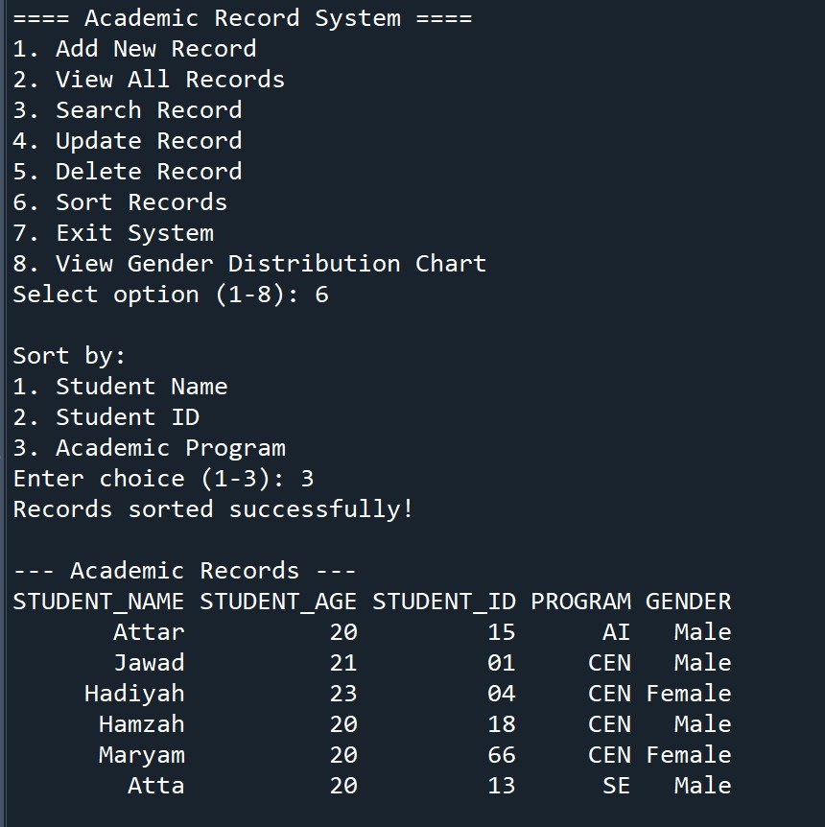

Exit System:
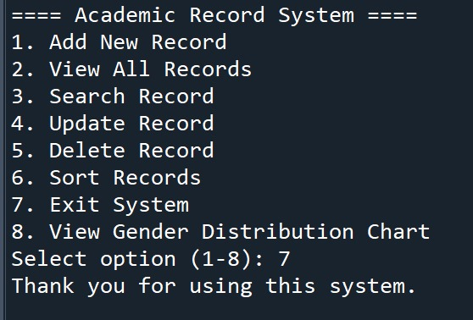

Additional Feature:

View Gender distribution chart
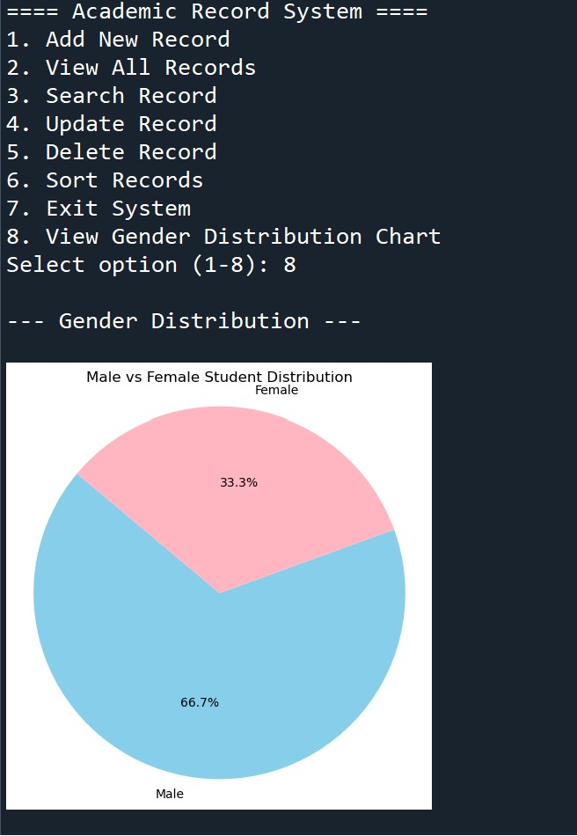

Conclusion:
This project showcases the effective use of Object-Oriented Programming (OOP) to build a functional Student Management System. By organizing data through classes and enabling features like adding, updating, searching, and deleting records, the system provides a structured and user-friendly experience. The integration of pandas ensures efficient data handling, while matplotlib offers a clear visual representation of gender distribution. The use of CSV files supports persistent data storage. Overall, the project demonstrates how OOP and Python libraries can be combined to develop real-world academic tools that are practical, scalable, and easily extendable for future educational system enhancements.

